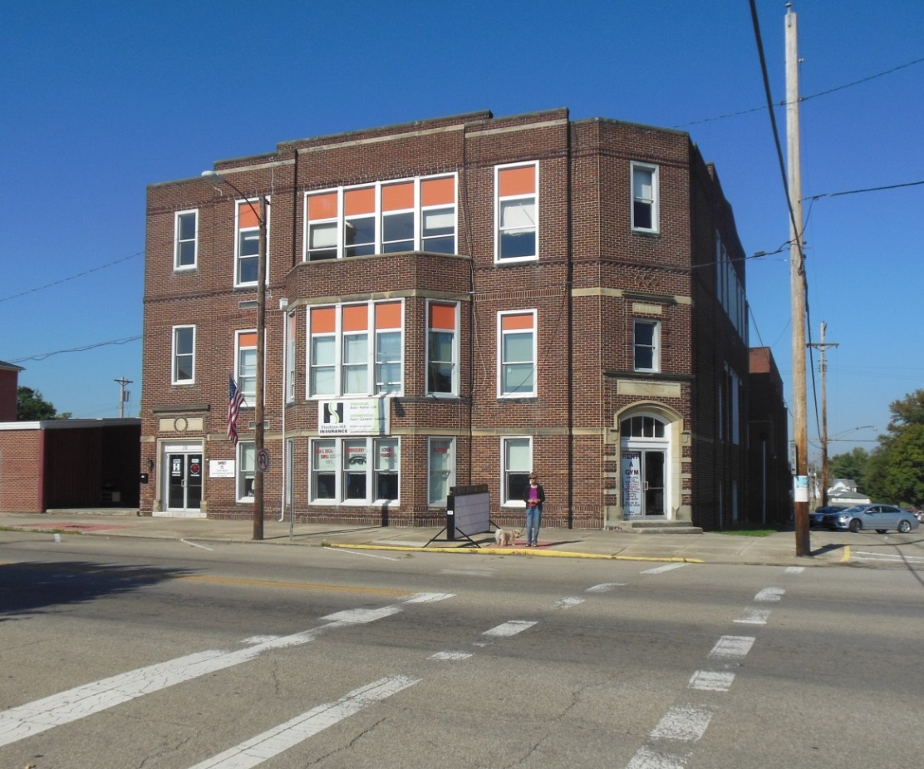

Kingston High – photograph taken – 2014

**Nelson Foster Wolfe and Family**

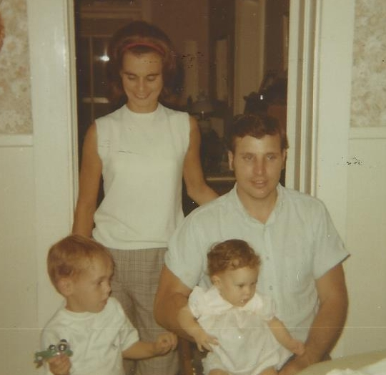

Nelson & Donna Wolfe with Brian & Elaine Moore - 10 Sept 1969